linux file systems - everything in linux is a file
- lsblk -f

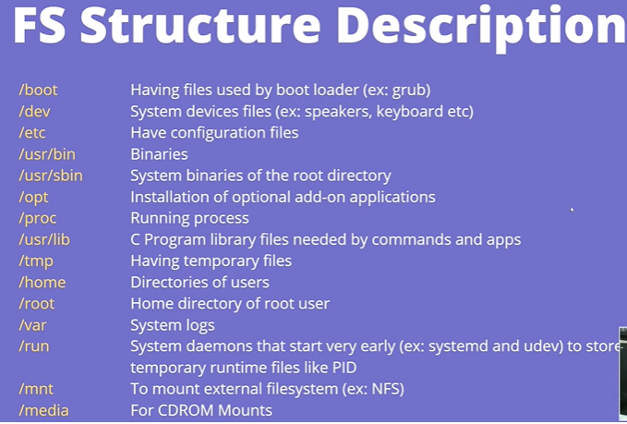
##commands
hostname - to know hostname of machine
whoami - current user
ip addr - to know ip of the machine
pwd
ls
mkdir
cd
clear
cd ../..
find path expression - to find the file in the specified path
touch filename
rmdir
rm -rf directory
vi - i, esc+shift:+wq
wc filename - wordcount , line word bytes
diff file1 file2 - difference between filees
tar cvf name.tar files - to tar the files
gzip files - to zip files
cp
gunzip name.gz , tar xvf name.tar - to unzip and untar
zip
mv
cat file1 file2 > filename
split -l 1 filename - to split a file in parts based on lines
id -- to find the details of current user
last --to check who logged in last
whoami
who --list of users logged in
w --what current logged in users doing
hostname
uname -r ---kernal info
ip a

## CP ---copy something
cp src_file/path dest_path

## need to be in wheel group to be sudo user.

##VI Editor - to edit files use it
vi filename
i insert , o insert on next line, esc escape out of of mode, :q! quit without saving
:wq! - quit and save ,a insert after space, r replace , d delete, u undo, x remove next caharacter
/ forward search, ? backward search

##Nano Editor
ctrl +x to save , ctrl+o to write to another file,
use the options given below in nano

##find and locate
find . -name/type/user/link filename
locate filename (as root do updatedb if not working)

##Grep global regular expression print
grep [options] pattern file/directory
grep nita filename, [options] -i to ignore case, -v search evrything except expression,
-c to get the count of word , -w to get exact match, -n to get line no., -e multiple keyword,
egrep "key|key|key" to find multiple key, -l to get filename,-f filename to get key from another file
-R /dir/ to find in the directory, -q to search but not print gives like true or false $? - 0true and 1 false

##Find
find path -name/type/user/link/size/perm file/d,f,l/root/M,G,K,C/777,/u=r to find anything as per req
find path -newer last.txt - all files which are created or modified after last.txt
find path -empty / find path -empty exec rm {} /;
find path -size +1M -size -50M
find path -mtime 15 - 15 days old files

## find largest file
find path -maxdepth -type f -exec ls -lh {}\; | sort -k5rh |head -1 |awk -F\ {print $NF}
(maxdepth doesn't go in directory but only give the file in current path)
du -sh * | sort -rh |head -1
ls -lhS | head -1

## Piping
ps -ef | grep httpd
ls -1 | wc -l - tocount files in directory
cat file1 file2 | sort | uniq
cat file1 | haed -38 | tail -7 - to see files from 30 to 37

tee command gives output and also writes in a file
ls | tee file1.txt | wc -l

xargs convers stdinput in command line arguments, cause some commands only take command line arguments
ls | xargs echo "hi"
cat file | xargs touch

## Wildcards * zero or more, ? single char, [] range of char
ls -l *.xml
touch file[1..10]
ls -l [abc]123
sed -n '/$s/p' file
sed -n '/^a/p' file

##Compree De-compress TAR- take archive
gzip filename - will give in zip filename.gz
gunzip filename or gzip -d filename
tar cvf name.tar files - to compress
tar -tf file.tar to read something in a tar file
tar -zcvf name.tgz files

## Links shortcuts that points to data in link
ln -s originaldata_location softlinkname - will be removed if data deleted
ln originaldata_location hardlinkname -- not deleted if data removed

##Environment variables -- dynamic-name value that can be used by a program
VARIABLE_NAME=VALUE
printenv/env - to see environments
echo $HOME
export TESTVAR=1 - to set temporary env

vi .bashrc
TESTVAR=1
export TESTVAR - this will create a permanent variables

vi etc/profile or /etc/bashrc
TESTVAR=1
export TESTVAR - will create a permanent global variable which will be there for all users

unset TESTVAR - to remove the env

##Redirection in linux >>/> append / redirect all
lscpu >>file
cd /root/ 2 > error_file - to get error in a file and not print the same in terminal
cd /root/ > error_file 2>&1 - to redirect error or output
cat < std_errorfile - to give input to command from file
wc -1 std_errorfile

## PS process status
ps - process running in current shell, TTY - terminal type of user logged in to
ps -e - all process in terminal
ps -ef - f for full format
ps aux - more info
ps -ef | grep httpd
ps -u/G user/group - to see precess of user or Group
ps -ejH - to see process tree

## Kill command
kill [Option] [PID] - option is signal name or number
kill pid - -1 to restart, -2 interrupt like CTRL+c, -9 to kill forcefully, -15 to kill properly

## TOP - info of real time view of running process
top - c to see path, n to see no. of tast, k to kill, d/s to change delay to refresh, M to sort by memory
r to chnage nice value, u to filter user wise, f field management, h help

## Manage process nohup, jobs, bg,fg,nice value -20 to 19
jobs - active jobs
bg/fg - resume jobs in background/ foreground
bg/fg %pid - to start job again
nice -n value process - to change nice value to change priority
nohup process & - to run the process even after closing the terminal
nohup process > /dev/null 2 > &1 & - this way no output will go to nohup outfile file

## system monitoring df, du , free
df -h -BK/G/M - to check memory
du -ah -BK/G/M folder - show disk use
free -h -s 3 - to see free ram memory, -s to refresh after 3 seconds

dmesg - display kernel related message, usually during start , which give infor of application
dmesg -HTx - (human redable time decode)
-w to live monitor , -c to clear message, -l different level emerg/alert/warn

## File permission
chmod u/g/o/a+-rwx filename
ACL - access control list --to give access to specific permissions to special user or group
getfacl filename
setfacl -m u:user:rwx/g:group:rwx filename --to modify file permission to specific user or group
-x to remove permission
-b to remove all entries

##SGID SUID shown as s/S
setting sgid or suid runs the files as the original user no matter who runs it, similarly setting sgid will assign the same group
to all the files created in a folder.so if sgid is set for dir any files created in that will have the same group as the setter.

## Sticky Bit shown as t/T
id this is set then only the owner of the file or the directory can delete or rename the same.
chmod o+t file/directory

## chown chgrp
to change owner or group

##USER management
whoami - to know current user
who --- to know who all logged in to the system
w -- to get info of currently logged in users

useradd [options] username -- can be used to create a new user
sudo useradd -m -d /Demo1 Demo1 --- -m to assign home dir and -d to specify the dir,
sudo useradd -d /home/test -e 2020-03-16 Demo2 --- -e to give expiry
/etc/passwd dir contains the user details

File /etc/default/useradd contains some user default options. The command useradd -D can be used to display this file.

Userdel -r <userName> --- to delete a user

paaswd username --- to change the password of the user

Shadow files are the encrypted user passwords which are kept in /etc/shadow. This file is read-only directory and can be read only by root

The /etc/login.defs file contains some default settings like password aging and length settings

chage -l <userName> --- to knwo passwd information
usermod -L/U <userName> -- to lock or unlock a user

## Cron jobs jobs that can be run periodically
crontab -l/e -- l to list e to add or edit
at command to run a job once
at hh:mm, atq to check at jobs, atrm# to remove at jobs

## SSH - secure shell , network communication protocol, 22 port byfault
ssh user@ip
ssh-keygen , ssh-copy-id user@ip - so to avoid using password evrytime we login we can generate the ssh key and the key to the
remote server.

## FTP - file transfer protocol - to transfer file between client and server
vsftpd is needed to be installed.
rpm-qa | grep vsftpd -- to check if vsftpd is installed
rpm -qa | grep vsftpd -- to check if vsftpd is installed
need to change the .conf file and then give firewall access and then only we can we can use ftp to transfer files
ftp ip --give credentials
put/mput filename --to transfer file , to transfer multiple file we can do mput
get --to download the file

## PING cmd
ping ip --to ping a server to check if connection is there, so if ping is working means we can connect to the server.

ping ww.google.com


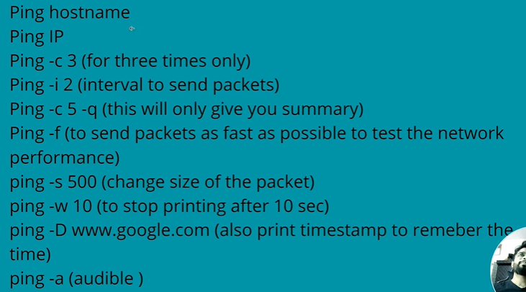

## netstat cmd --for network monitor and troubleshoot
netstat -putan | grep port/ip -- to check no. of conection on port or ip (process,udp,tcp,all,numeric)

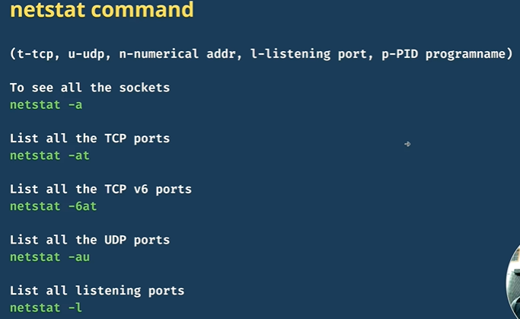

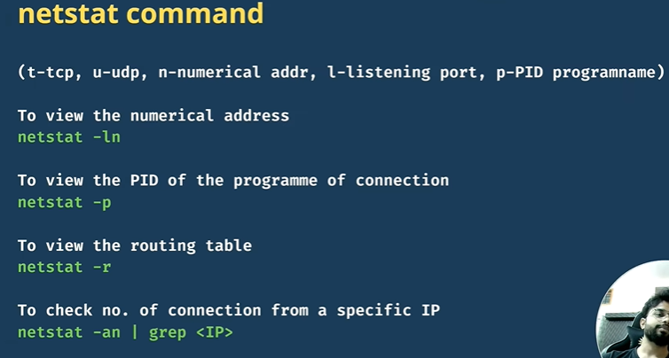
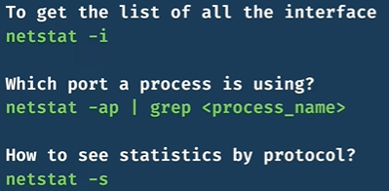

## awk --text processing cmd, to search expressions in a file
awk '{pattern}' filename
eg -

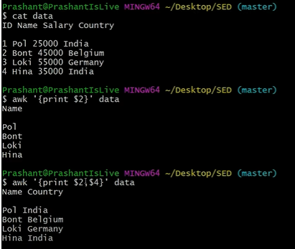
awk '{print $2}' data
awk '{print $NF}' data --to print last column
awk '{print NR, $0}' data --to get the data with the line numbers.
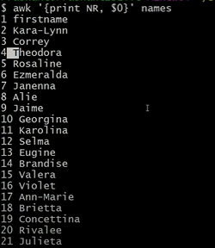
Awk '{print NR ": " $0}' data --to get line no. With : format 1: , 2: ,3: ,

we may have file where data won't be space seperated so

awk -F, '{print $4}' filename -- to specify the seperator/delimiter we can give -F and seperator
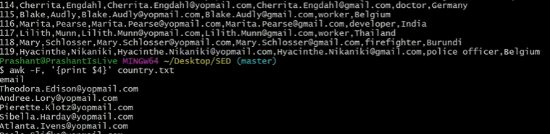
we can also use conditions, loops in awk cmd
awk '{if ($3>45000) print $0}' filename
awk '{if ($2=="pol") {$3=50000} $0}' filename
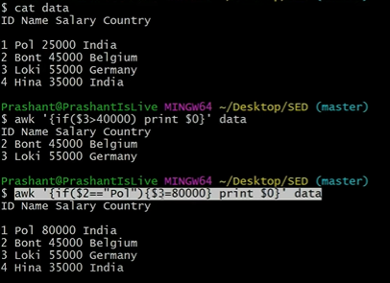
awk '/india/ {print $0}' file --will print all the line in the file where india is matched

awk 'NR=="8", NR=="10" {print $0}' filename --will print only the data of line no. 8

awk 'NF==0 {print NR}' filename --print line where line is empty

awk 'END {print NR}' filename --to print the last line or to know how many lines r there

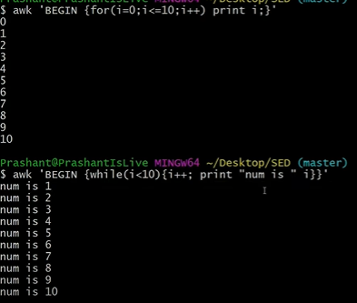
## cut cmd -- used when we need processing at the character level
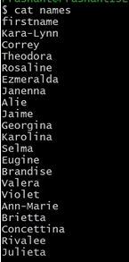
cut -c1 name --to get 1st char of all line
cut -c1,5 name --to get 1st and 5th char of all line
cut -c1-5 name -- to get 1-5 char

we can also use cut for csv file where we can specify the delimiter and -f we want and then get the data for the same.

Cut -d, -f 4 filename --delimiter is , and field req is 4th

we can also change the delimiter from , to something else
cut -d, -f 1- filename –output-delimiter= " : " --, will change to :

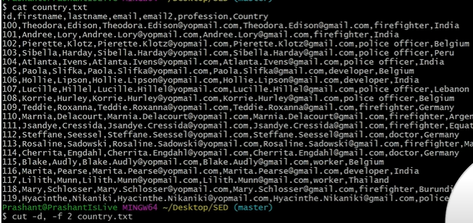

##sed CMD --to get replace insert or delete expressions
sed ' ' filename

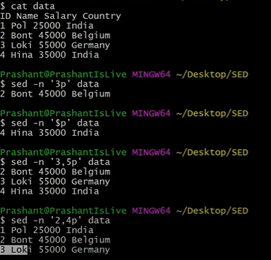
sed -n '2p' filename --print 2nd line
sed -n '/india/p' filename --print file name where india is present
sed -n -e '2p' -e '4p' filename --use -expression option to get multiple line
sed -n -e '/india/p' -e '/Germany/p' filename

we can also use sed to replace a word

sed 's/pol/paul/g' filename --substitute pol with paul globally

sed '2 s/pol/paul/g' filename --to change only 2nd line

sed '/pol/ s/india/us/g' filename -- change coutry from india to us if pol is found

sed '1d' filename --to delete 1st line

sed '/^$/d' filename --to delete empty line

sed '3 a/c/i data ' filename --to add data after 3rd line

sed -n 'l' filenam -- to see hidden chars

##Send Mail
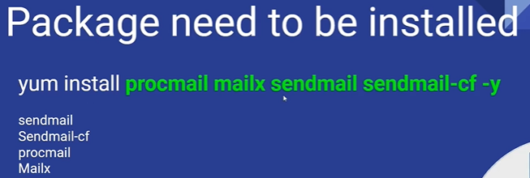
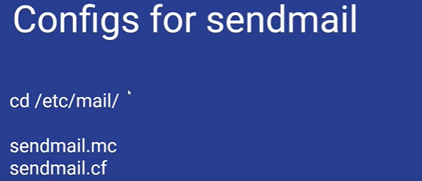


To install all the required packages
# yum install procmail mailx sendmail sendmail-cf -y
In your authinfo file, you need to add the below line (Please make sure to use your own username and password)

AuthInfo:smtp.gmail.com "U:your_username" "P:your_password" "M:PLAIN"
Changes in sendmail.mc
define(`SMART_HOST', `smtp.gmail.com') FEATURE(`authinfo')

Update sendmail.cf and authinfo.db file
# m4 sendmail.mc > sendmail.cf
# makemap hash authinfo < authinfo

Restart your sendmail service
# systemctl restart/start sendmail

To send mail
# mail -s “Subject” user@email.com
Body
Ctrl + D
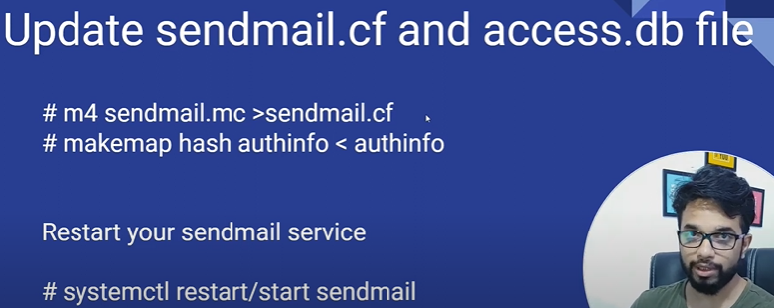

###### SHELL SCRIPT #########
echo $0 ---to get shell name

to run ./.sh file

variables - name = aman
age = 26

echo $name $age ---to call variable use $

host=$(hostname) --if we want to use linux variables

read name -- to accept variable as input

## if -else

if [condition]
then
body
else
body
fi
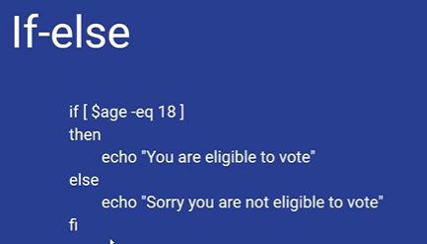

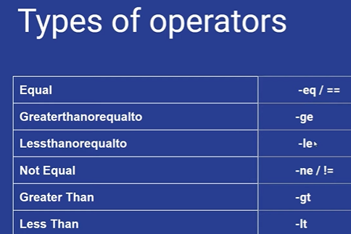
## Switch case

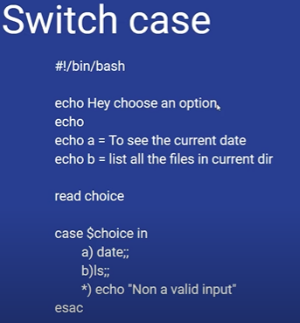
## LOOPS



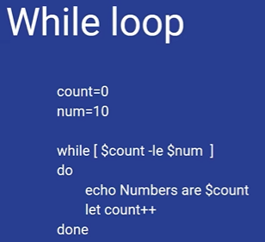
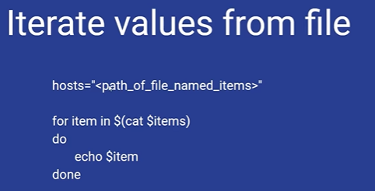

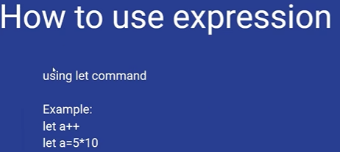

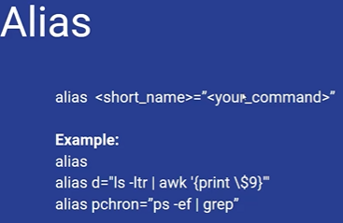

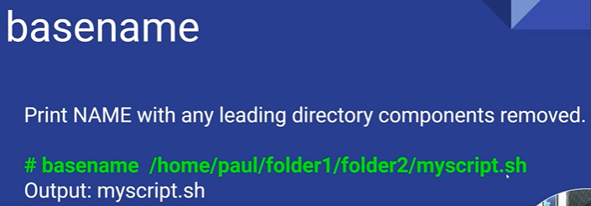
so we can give echo "the name is $(basename ${0})"

